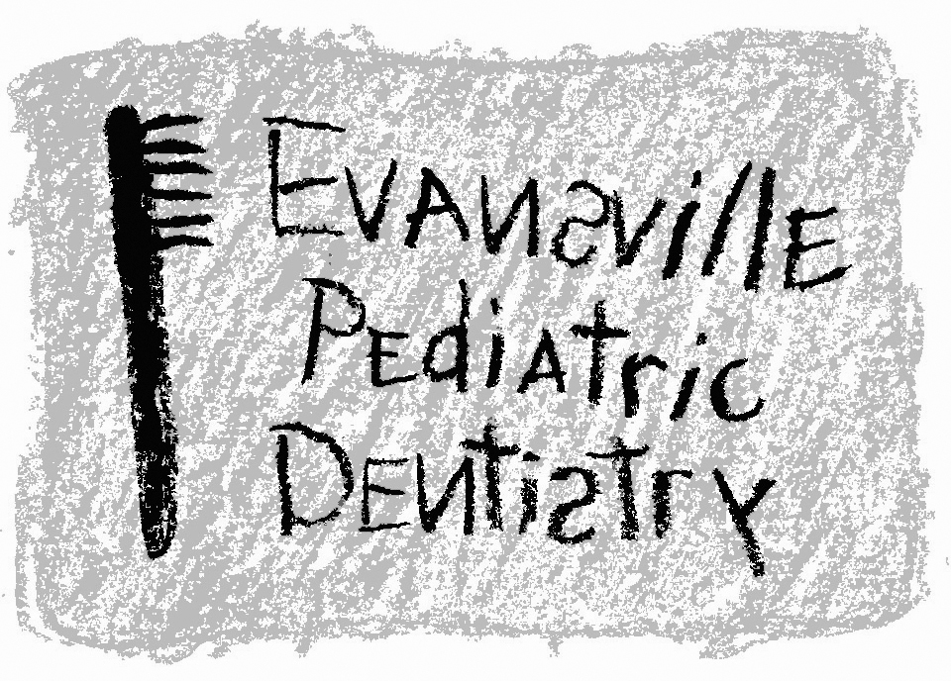
Jeffrey A. Hiester, D.D.S.
EAST WEST
7200 E. Virginia Street 2345 W. Franklin Street #101
Evansville, IN 47715 Evansville, IN 47712
(812) 479-8609 (812) 401-6095

HOME CARE INSTRUCTIONS

ACTIVITY: The medication may still affect your child for 24 hours. Whether he/she feels drowsy or seems fully awake, they may lack their usual coordination. Your child needs careful watching to prevent falls and accidents.

NAUSEA: Your child may experience some nausea or vomiting from the anesthesia. If so, please only give clear liquids until the nausea/vomiting has stopped.

DIET: Your child can be given clear liquids (ice chips, 7-up, Gatorade, Jell-O, or any liquid you can see through) for the first 1-2 hours. If your child has no problems with nausea, then he/she may have a “light” meal (soup, ice cream, crackers, etc.). Should vomiting occur, return to the clear liquid diet. A soft bland diet may be tolerated easily for the first 1-2 days. If there is no nausea or vomiting, your child can gradually eat solid foods after the first few hours. Please do not allow your child to hard or sticky candy from now on, as this can damage the teeth that were fixed.

PAIN: It is important that your child be kept comfortable during the healing time following dental treatment. We commonly see children refuse to eat or drink when they are having severe mouth pain. Acetaminophen or ibuprofen medications should be given per the instructions on the package. Avoid the use of aspirin.

CARE OF MOUTH: It is of vital importance that the teeth be cleaned during the initial healing stages. Remember the Rule of 3’s. Teeth need to be brushed three times a day for three minutes at a time during the first three weeks following dental treatment. This brushing must be done by an adult since children will be very reluctant to properly brush their teeth. Use only a soft bristled toothbrush to brush their teeth. It may help to run warm water over the toothbrush to soften the bristles. It is normal to notice a small amount of bleeding after brushing the teeth.

WHAT TO EXPECT: It is common for a slight amount of bleeding to continue for 2-3 hours following any extractions or extensive treatment. This small amount of blood usually appears excessive because it is mixed with saliva. Should an abnormal amount of bleeding occur, it can be easily controlled by taking a moist wash cloth and having your child bite on it (applying pressure to the bleeding area). Pressure for 10-15 minutes will control minor bleeding. It is common to have a low grade fever for the first 24 hours. Acetaminophen or ibuprofen medications should control the fever.

WHEN TO CALL THE DENTIST:
- Noisy or difficult breathing
- Refusal to eat after the first 12 hours following treatment
- Persistent vomiting
- Fever over 101 F
- Excessive bleeding
- Persistent pain

Once you are home and you have any questions or concerns, please call our office at (812) 479-8609 or my cellular phone at (812) 459-6141.

Thanks,

Dr. Jeff Hiester

